# Submitted By: Mureed Qasim Shah – Pegasus_Python

# Docker Assignment 1:

## Task 1: Build the node-app Image

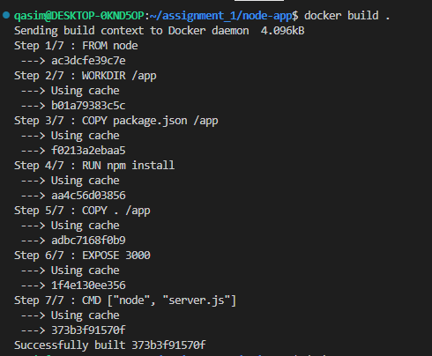

## Task 2: Run the Image to create a Container



So here you can see in the above picture that I am listening at port 3000 and mapping it at port 3004.

## Task 3: Output

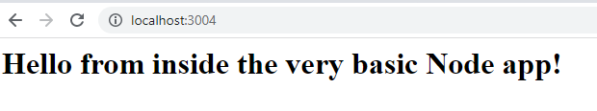

So here you can see that my application is up and running.

## Task 4: Stop the running container

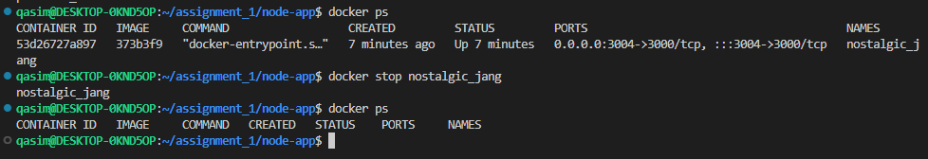

## Task 5: Rename the container and Restart and Stop it.

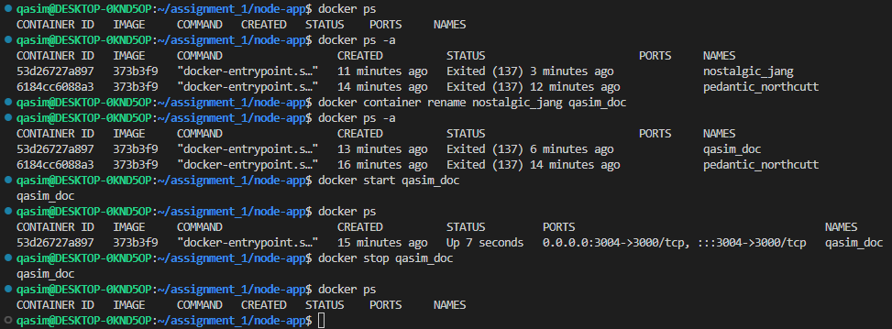

## Task 6: Clean up (remove) all stopped (and running) containers, clean up all created images.

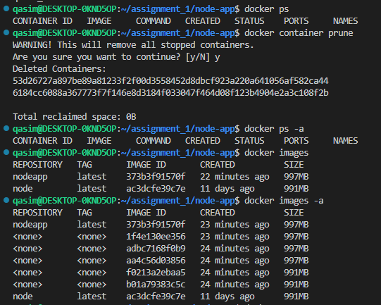

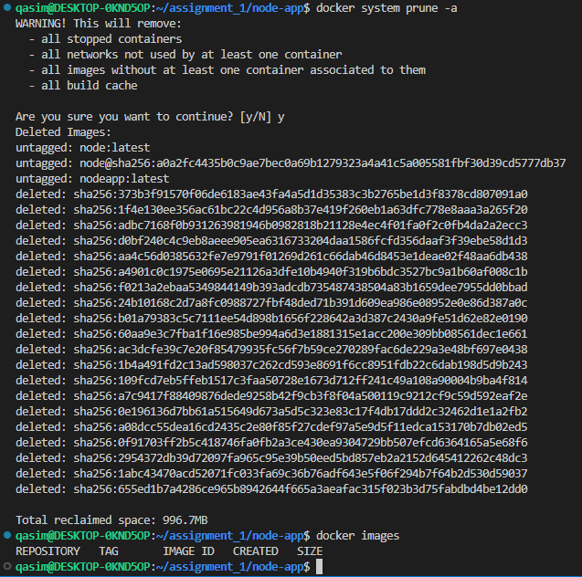

## Task 7: Re-build the images - this time with names and tags assigned to them.



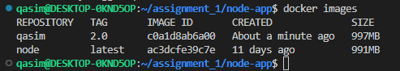

## Task 8: Run new containers based on the re-built images, ensuring that the containers are removed automatically when stopped.



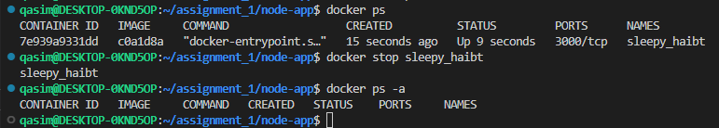

# 2. Second Python Application

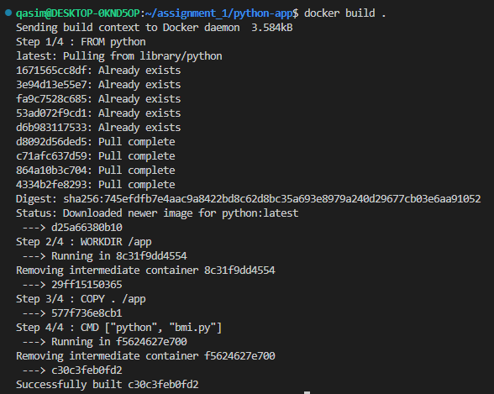

## Output:

